Lesotho

## GNI per capita and development level

The data set shows the GNI per capita and development level of the country each year.

## # A tibble: 19 x 5  
## country iso3c date GNIperCapita devCategory   
## <chr> <chr> <dbl> <dbl> <chr>   
## 1 Lesotho LSO 1996 3663. Lower Middle Income  
## 2 Lesotho LSO 1998 3663. Lower Middle Income  
## 3 Lesotho LSO 2000 3663. Lower Middle Income  
## 4 Lesotho LSO 2002 3207. Lower Middle Income  
## 5 Lesotho LSO 2003 3841. Lower Middle Income  
## 6 Lesotho LSO 2004 3846. Lower Middle Income  
## 7 Lesotho LSO 2005 3846. Lower Middle Income  
## 8 Lesotho LSO 2006 3846. Lower Middle Income  
## 9 Lesotho LSO 2007 1425. Lower Middle Income  
## 10 Lesotho LSO 2008 1495. Lower Middle Income  
## 11 Lesotho LSO 2009 1459. Lower Middle Income  
## 12 Lesotho LSO 2010 1503. Lower Middle Income  
## 13 Lesotho LSO 2011 1517. Lower Middle Income  
## 14 Lesotho LSO 2012 1550. Lower Middle Income  
## 15 Lesotho LSO 2013 1572. Lower Middle Income  
## 16 Lesotho LSO 2014 1576. Lower Middle Income  
## 17 Lesotho LSO 2015 1551. Lower Middle Income  
## 18 Lesotho LSO 2016 1617. Lower Middle Income  
## 19 Lesotho LSO 2017 1588. Lower Middle Income

## GDP growth and economic growth classification

The data set shows the GDP growth and the ecomic growth classification of the country each year.

## # A tibble: 19 x 5  
## country iso3c date GDPannualGrowthRate GDPgrowthCategory4  
## <chr> <chr> <dbl> <dbl> <fct>   
## 1 Lesotho LSO 1996 5.60 fast growth   
## 2 Lesotho LSO 1998 1.54 slow growth   
## 3 Lesotho LSO 2000 3.88 moderate growth   
## 4 Lesotho LSO 2002 0.724 slow growth   
## 5 Lesotho LSO 2003 4.56 moderate growth   
## 6 Lesotho LSO 2004 1.69 slow growth   
## 7 Lesotho LSO 2005 3.47 moderate growth   
## 8 Lesotho LSO 2006 4.23 moderate growth   
## 9 Lesotho LSO 2007 4.83 moderate growth   
## 10 Lesotho LSO 2008 6.74 fast growth   
## 11 Lesotho LSO 2009 2.15 slow growth   
## 12 Lesotho LSO 2010 0.825 slow growth   
## 13 Lesotho LSO 2011 5.36 moderate growth   
## 14 Lesotho LSO 2012 6.74 fast growth   
## 15 Lesotho LSO 2013 4.19 moderate growth   
## 16 Lesotho LSO 2014 2.88 moderate growth   
## 17 Lesotho LSO 2015 2.65 moderate growth   
## 18 Lesotho LSO 2016 5.05 moderate growth   
## 19 Lesotho LSO 2017 -1.32 negative grwoth

## Development trend

The plot shows the development trend of the country.

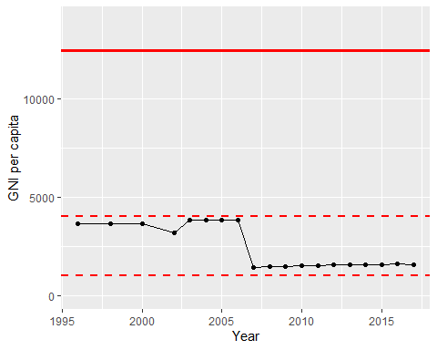

GNI Per Capita Trend